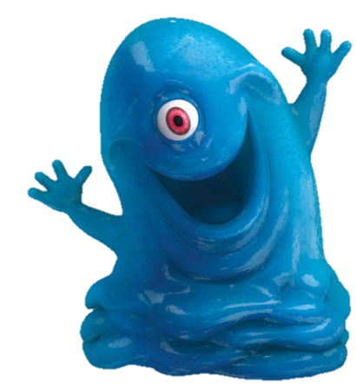
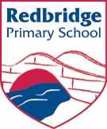
Redbridge Primary School Weekly Planning Grid
Week Beginning 15th June 2020
Nursery Monsters and Aliens
Topic Based Project Work

Design and sew your own sock monster or alien. | Make SLIME! | Using playdough/slime to make an alien/monster and mould into different shapes. | Bake something out of this world!
Make a 2D shape monster/alien! | Read ‘Whatever Next’ or other alien/monster stories. | Make rockets/spaceships using tubes/different shapes. | Use a colander to make an alien/monster to practice Fine Motor Control!
Draw a picture of space for an alien far, far away! What does space or an alien look like to you? | Listen to the planet song to learn all about our different planets (the link is on the last page). | Junk modelling challenge: make a monster/alien out of junk! | Watch the movie Monsters Inc. (or something similar!) Do they all look the same? What makes them different?

Maths and English Sequence
English Day 1  STARTER:  Watch the story ‘Aliens Love Underpants’ on YouTube (or if you have the book, read it!)  MAIN:  Using the underpants template, collage a pair of underpants for the aliens to wear (paint, tissue paper, pom poms, glitter. Make them as fun as possible!) | English Day 2  STARTER:  Make a rocket name using the pictures shown on the last page as prompts.  MAIN:  Using the ‘Monster Alphabet Cards’ template, place the letters in a bag - ‘s,a,t’ (Phase 2 Set 1) OR ‘s,a,t,p,i,n’ (Phase 2, Set 1 and 2) OR s,a,t,p,i,n,  m, d, g, o, c, k, e, u, r (Phase 2, Set 1,2,3 and 4) depending on your child’s Phonic Level.  Pick out a letter and ask child to say the sound and repeat the action. | English Day 3  STARTER:  Listen to the ‘Zoom Zoom Zoom’ song on YouTube.  MAIN:  Using the monster alphabet cards from yesterday, get your child to find the letters of their name and practice writing the letters (children may need to copy over letters that you have modelled first). | English Day 4  STARTER:  Watch the story ‘Monsters Love Underpants’ on YouTube.  MAIN:  Using playdough/plasticine or other malleable materials, make an alien or monster (look at the pictures below for some inspiration!). | English Day 5  FRIDAY FUN:  Using hand and foot prints, make a set of ‘Little Monsters’. These can go in children’s Nursery Home Learning Books.  Tip:  If you do not want to paint your child’s hand/feet, simply draw around them and decorate!
Resources  -YouTube  -Underpants -Template  -Paper  -Paint and Paint Brush  -Colouring Pencils/Pens  -Glitter  -Sequins  -Whatever you have to decorate! | Resources  -Paper  -Pencil  -Alphabet Cards  (Use Jolly Phonics website to support teaching phonics!) | Resources  -YouTube  -Alphabet Cards  -Pencil | Resources  -YouTube  -Playdough/Other Malleable material  -Pipe Cleaners  -Sequins | Resources  -Paint  -Paper  -Hands and Feet!
Maths Day 1  STARTER:  Listen to the song ‘5 Little Men in a Flying Saucer’.  MAIN:  Using the ‘Alien Spaceship Counting’ sheet, ask your child to place put a number of aliens in the spaceship – ‘can you put 4 aliens in the spaceship?’ – ‘can you put 7 aliens in the spaceship?’ | Maths Day 2  STARTER:  Complete a ‘Colour by Number Alien’ sheet. Can children match the colour to the correct number?  MAIN:  With support, child to complete the ‘Alien Counting’ Worksheet (there is one to 10 and one to 20 depending on your child’s level). | Maths Day 3  STARTER:  Hide 2D shapes around your home and ask your child to find and name them (2D Shape Hunt).  MAIN:  Cut out some 2D shapes (square, circle, triangle, rectangle, star and diamond). Make 2D shape monsters and give them a name. | Maths Day 4  STARTER:  Listen to the song ‘5 Little Monsters’.  MAIN:  Using a cardboard box (medium size), make a rocket using different 2D shapes for windows, doors, lights, fire etc.  There are pictures below for ideas! | Maths Day 5  FRIDAY FUN:  Make 2D Shape alien/monster biscuits using the recipe on an attached sheet.  Roll out the biscuit dough to make different 2D shapes and then children can decorate them once cooked to look like monsters/aliens. Take pictures of children creations!
Resources  YouTube  Scissors  Glue  Worksheet | Resources  -Worksheets  -Colouring Pencils | Resources  -Paper to make 2D shapes  -Scissors  -Glue | Resources  -YouTube  -Cardboard Box  -2D Shapes  -Scissors  -Glue  -Colouring Pencils | Resources  *Look at the recipe for details on ingredients*
Don’t forget to share any of your wonderful learning and photos with the school. You can email photos and work to admin.redbridgeprimary@redbridge.gov.uk
YouTube Links:
Zoom Zoom Zoom Song: https://www.youtube.com/watch?v=DEHBrmZxAf8
Aliens Love Underpants Story: https://www.youtube.com/watch?v=ADnAGBWlzqE
Monsters Love Underpants Story: https://www.youtube.com/watch?v=xJKxuSDj9pk
5 Little Men Song: https://www.youtube.com/watch?v=2E3p_51tJx0
5 Little Monsters Song: https://www.youtube.com/watch?v=E0bqk2FScog
Planet Song: https://www.youtube.com/watch?v=BZ-qLUIj_A0
Rocket Name Idea: Playdough Aliens/Monsters:
